**Dal sito WEB di: CHRONOMADDOX**

|  |
| --- |
| **Omega Speedmaster Evolution by Roman Hartmann...** |

|  |  |  |  |  |  |  |
| --- | --- | --- | --- | --- | --- | --- |
| **Year:** | **Case Reference Numbers:** | | | **Calibre:** | **Serial Numbers:** | |
| 1969 | ST 145.022 |  | | 861 | 26xxxxxxx | 27xxxxxxx |
| 1970 | ST 145.022 | ST 145.0022 |  | 861 | 28xxxxxxx | 30xxxxxxx |
| 1971 | ST 145.0022 |  | | 861 | 30xxxxxxx | |
| 1972 | ST 145.0022 |  | | 861 | 31xxxxxxx | |
| 1973 | ST 145.0022 |  | | 861 | 31xxxxxxx | 32xxxxxxx |
| 1974 | ST 145.0022 |  | | 861 | 32xxxxxxx | |
| 1975 | ST 145.0022 |  | | 861 | 33xxxxxxx | |
| 1976 | ST 145.0022 |  | | 861 | 34xxxxxxx | |
| 1977 | ST 145.0022 |  | | 861 | 35xxxxxxx | 36xxxxxxx |
| 1978 | ST 145.0022 |  | | 861 | 37xxxxxxx | |
| 1979 | ST 145.0022 |  | | 861 | 38xxxxxxx | 39xxxxxxx |
| 1980 | ST 145.0022 |  | | 861 | 40xxxxxxx | 41xxxxxxx |
| 1981 | ST 145.0022 |  | | 861 | 42xxxxxxx | |
| 1982 | ST 145.0022 |  | | 861 | 43xxxxxxx | |
| 1983 | ST 145.0022 |  | | 861 | 44xxxxxxx | |
| Watches with cal. 863 or cal. 1863 and LE don't fit into this table (some of them do, though)  [rhartmann@bluewin.ch](mailto:rhartmann@bluewin.ch)  Roman Hartmann | | | | | | |

**Dal sito WEB di: IALREADYHAVEAWATCH**

**Omega Serial Numbers by Year**

**Table for Dating Vintage Omegas by Serial Number and Year**

|  |  |  |  |  |
| --- | --- | --- | --- | --- |
| **Serial Number** | **Earliest Production Year**[**A**](http://ialreadyhaveawatch.com/watch-articles/omega/omega-serial-numbers-by-year/#foot_a) | **Produced thru**[**B**](http://ialreadyhaveawatch.com/watch-articles/omega/omega-serial-numbers-by-year/#foot_b) | **Used in low production** [**C**](http://ialreadyhaveawatch.com/watch-articles/omega/omega-serial-numbers-by-year/#foot_a) | Speedmaster Only[D](http://ialreadyhaveawatch.com/watch-articles/omega/omega-serial-numbers-by-year/#foot_b) |
| 14,000,000 | 1954 | 1956 | 1958 | 1957 |
| 15,000,000 | 1956 | 1958 | 1962 | 1958 |
| 16,000,000 | 1958 | 1961 |  | 1958-1959 |
| 17,000,000 | 1959 | 1961 | 1963 | 1960 |
| 18,000,000 | 1961 | 1963 | 1964 | 1961-1962 |
| 19,000,000 | 1962 | 1963 |  | 1962 |
| 20,000,000 | 1963 | 1964 | 1967 | 1963 |
| 21,000,000 | 1964 | 1965 | 1966 | 1963 |
| 22,000,000 | 1965 | 1966 | 1969 | 1964-1965 |
| 23,000,000 | 1966 | 1968 |  | 1966 |
| 24,000,000 | 1966 | 1967 | 1969 | 1967 |
| 25,000,000 | 1967 | 1969 |  | 1967 |
| 26,000,000 | 1968 | 1968 | 1970 | 1968-1969 |
| 27,000,000 | 1968 | 1969 | 1970 | 1969 |
| 28,000,000 | 1969 | 1969 | 1970 | 1970 |
| 29,000,000 | 1969 |  |  | 1970[F](http://ialreadyhaveawatch.com/watch-articles/omega/omega-serial-numbers-by-year/#foot_f) |
| 30,000,000 | 1969 |  |  | 1970-1971 |
| 31,000,000 | 1969 |  |  | 1972-1973 |
| 32,000,000 | 1970 |  |  | 1973-1974 |
| 33,000,000 | 1971 |  |  | 1975 |
| 34,000,000 | 1972 |  |  | 1976 |
| 35,000,000 | 1972 |  |  | 1977 |
| 36,000,000 | 1973 |  |  | 1977 |
| 37,000,000 | 1973 |  |  | 1978 |
| 38,000,000 | 1974 |  |  | 1979 |
| 39,000,000 | 1975 |  |  | 1979 |
| 40,000,000 | 1977 |  |  | 1980 |
| 41,000,000 | 1978 |  |  | 1980 |
| 42,000,000 | 1979 |  |  | 1981 |
| 43,000,000 | 1979 |  |  | 1982 |
| 44,000,000 | 1980 |  |  | 1983 |
| 45,000,000 | 1982 |  |  | 1984 |

**Dal sito WEB di:Pocket Watch Repair**

Omega Watch Company

Omega Serial Numbers and Production Dates

Note that Omega began using ETA movements in some of its watches in about 1980. This table does not include accurate dates for Omega/ETA movements.

|  |  |
| --- | --- |
| **Year** | **S/N** |
| 1959 | 16,700,000 |
| 1960 | 17,400,000 |
| 1961 | 18,000,000 |
| 1962 | 19,000,000 |
| 1963 | 20,000,000 |
| 1964 | 21,000,000 |
| 1965 | 22,000,000 |
| 1966 | 23,500,000 |
| 1967 | 25,000,000 |
| 1968 | 26,000,000 |
| 1969 | 27,000,000 |
| 1970 | 29,000,000 |
| 1971 | 33,000,000 |
| 1972 | 34,000,000 |
| 1973 | 36,000,000 |
| 1974 | 38,000,000 |
| 1975 | 39,000,000 |
| 1977 | 40,000,000 |
| 1978 | 41,000,000 |
| 1979 | 42,000,000 |
| 1980 | 44,000,000 |
| 1982 | 45,000,000 |
| 1984 | 46,000,000 |
| 1985 | 48,000,000 |
| 1986 | 49-50,000,000 |
| 1989 | 51,000,000 |
|  | 52m not used |
| 1991 | 53,000,000 |
| 1993 | 54,000,000 |
| 1995 | 55,000,000 |
| 1998 | 56,000,000 |

**Dal sito WEB di: SWEEPING HAND**

|  |  |
| --- | --- |
| **Omega Movement Number** | **Year** |
| 23m | 1966 |
| 24m | 1967 |
| 26m | 1968 |
| 27m | 1969 |
| 28m | 1970 |
| 30m | 1971 |
| 31m | 1972 |
| 32m | 1973 |
| 32m | 1974 |
| 33m | 1975 |
| 34m | 1976 |
| 35m | 1977 |
| 37m | 1978 |
| 38m | 1979 |
| 40m | 1980 |
| 42m | 1981 |
| 43m | 1982 |
| 44m | 1983 |
| 45m | 1984 |
| 46m | 1985 |

**Tabella OMEGA**

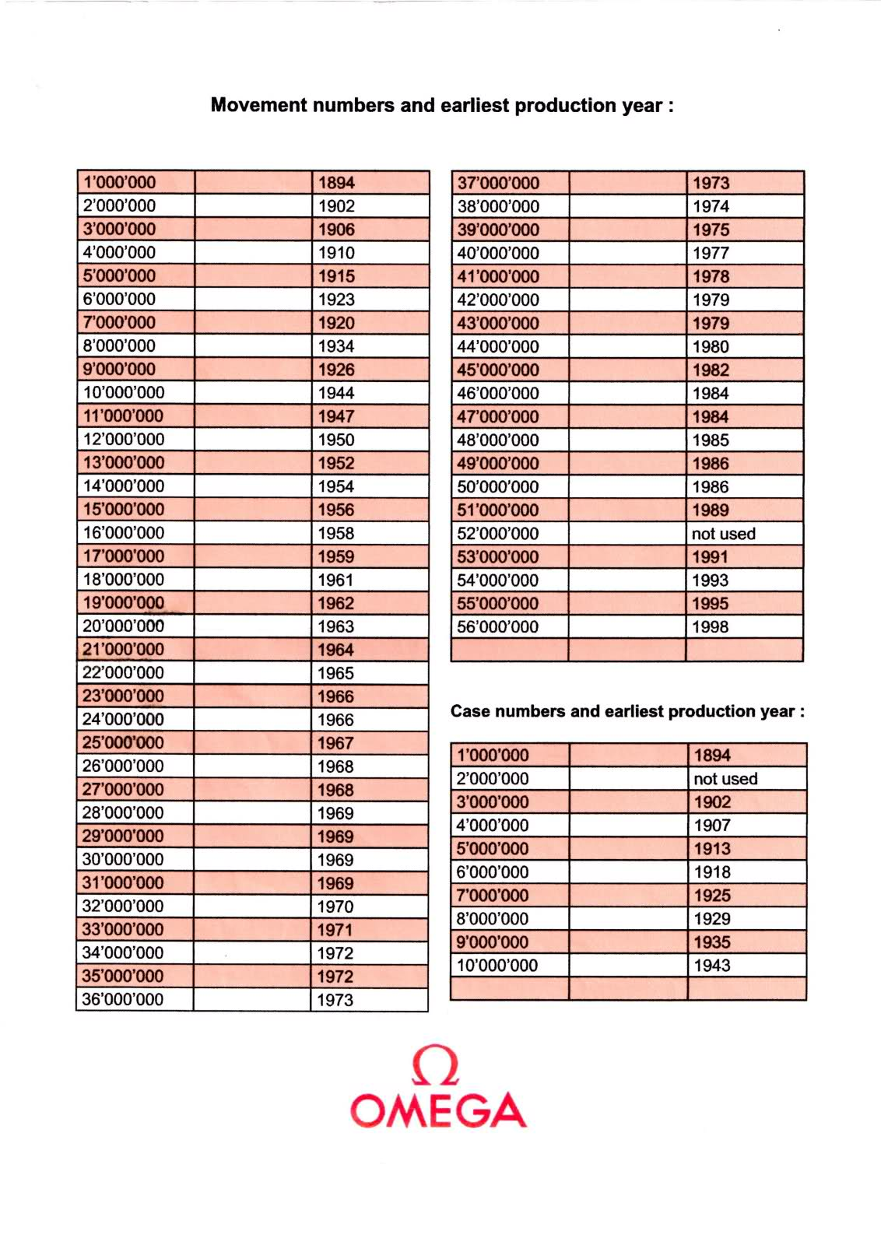

**Dal sito WEB di WATCH FINDER**

